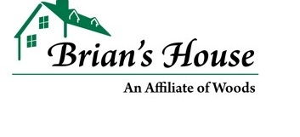

Brian’s House is Hiring!
Direct Care Counselors are needed to support adults with developmental and intellectual disabilities in Chester County. No experience is necessary – paid training in all aspects of direct care is provided. Flexible scheduling allows you to continue your education whilst gaining experience which greatly benefits a career in:
- Psychology
- Sociology/Social Work
- Special Education/Adult Education
- Nursing/General Healthcare
For more information, feel free to text or call our HR Department at 484-473-4649. We hope to be a part of the beginning of your career!
Benefits (Full-time employees):
- Medical/Dental/Vision
- Short & Long term disability, Life, Accident Insurance
- 24/7 access to telemedicine and Employee Assistance Program
- 10 paid holidays; PTO
- Tuition Reimbursement & Student Loan Assistance; Discounted tuition at Capella University

Locations:
- Thornton, Broomall, West Chester, Exton, Chadds Ford, Downingtown, Coatesville, Cochranville, Malvern, Paoli, Phoenixville

